**CMPT 412 Computational Vision**

**Report- Project 3**

***Object Detection, Semantic Segmentation, and Instance Segmentation***

**Kaggle Id Best score** – 0.82496

**Part 1: Object Detection**

In this part, it is asked to work with [iSAID](https://captain-whu.github.io/iSAID/) dataset. The standard dataset consists of 198 training and 72 test images with one category named “Plain”. First the dataset is loaded and, then the same and metadata is registered in the “DatasetCatalog”. The loaded data then get trained by setting the configs. The trained data is evaluated and hence, the visualizations of random samples if the test data are generated.

**List of the configs and modifications**

Below is the **list of configs** that are used for training the training dataset. The code is taken from the cell “**Set Configs”** from the l**ab3.ipynb** provided in the submission. As shown below, some of the modifications that are used to train the model are Num_Workers, IMS_PER_BATCH, BATCH_SIZE_PER_IMAGE, NUM_CLASSES, MODEL.WEIGHTS.

cfg = get_cfg()

cfg.OUTPUT_DIR = "{}/output/".format(BASE_DIR)

cfg.merge_from_file(model_zoo.get_config_file("COCO-Detection/faster_rcn n_X_101_32x8d_FPN_3x.yaml"))

cfg.DATASETS.TRAIN = ("my_dataset_train",) cfg.DATASETS.TEST = () #("my_dataset_test",)

cfg.DATALOADER.NUM_WORKERS = 4 #cfg.MODEL.WEIGHTS =

model_zoo.get_checkpoint_url("COCO-Detection/faster_rcnn_R_101_FPN_3x.ya ml") # Let training initialize from model zoo

cfg.MODEL.WEIGHTS =

model_zoo.get_checkpoint_url("COCO-Detection/faster_rcnn_X_101_32x8d_FPN _3x.yaml") # Let training initialize from model zoo cfg.SOLVER.IMS_PER_BATCH = 2

cfg.SOLVER.BASE_LR = 0.00025 cfg.SOLVER.MAX_ITER = 1500 cfg.MODEL.ROI_HEADS.BATCH_SIZE_PER_IMAGE = 512 cfg.MODEL.ROI_HEADS.NUM_CLASSES = 1

**Improvement Factors and Explanation**

The model is trained with different modification values. Below are the factors which helped in improving the performance.

**● Increasing the maximum iterations:**

The model was trained with the original iterations of 500. But the total loss recorded was not very low. Hence, the iterations were increased to 1000 and 1500. The model was trained and tested for the higher iteration values, and it is reported that the total loss was

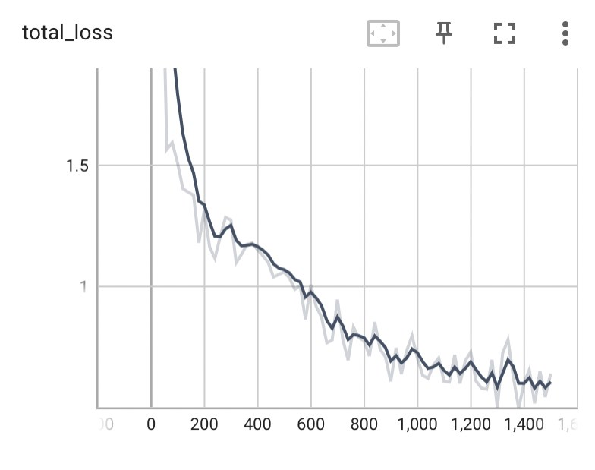

ranging between 0.58 - 0.63. Thus, the maximum iteration value was increased to 1500 for the final model.

**● Switch the model weight to faster rcnn:** The moel_zoo is changed to “

**COCO-Detection/faster_rcnn_X_101_32x8d_FPN_3x.yaml**” . It is studied and observed that the model has longer training time, improved FPN that is responsible for multi-scaling feature representation which improves the detection performance.

**● Increase cfg.DATALOADER.NUM_WORKERS**

Originally the model was trained with 2 numbers of workers but later it was increased and fixed to 4. Increasing the same to some extent can speed up the data loading and improve the data training process. In my model the value is set to 4 and the model is trained by varying other parameters.

**Plot for total training loss and accuracy**

Below is the plot for total training loss. The **total_loss** for **1500** iterations came out to be **0.63.**

Below are the accuracy plots for **fast_rcnn/cls_accuracy**, **fast_rcnn/false_negative**, and f**ast_rcnn/fg_cls_accuracy**.

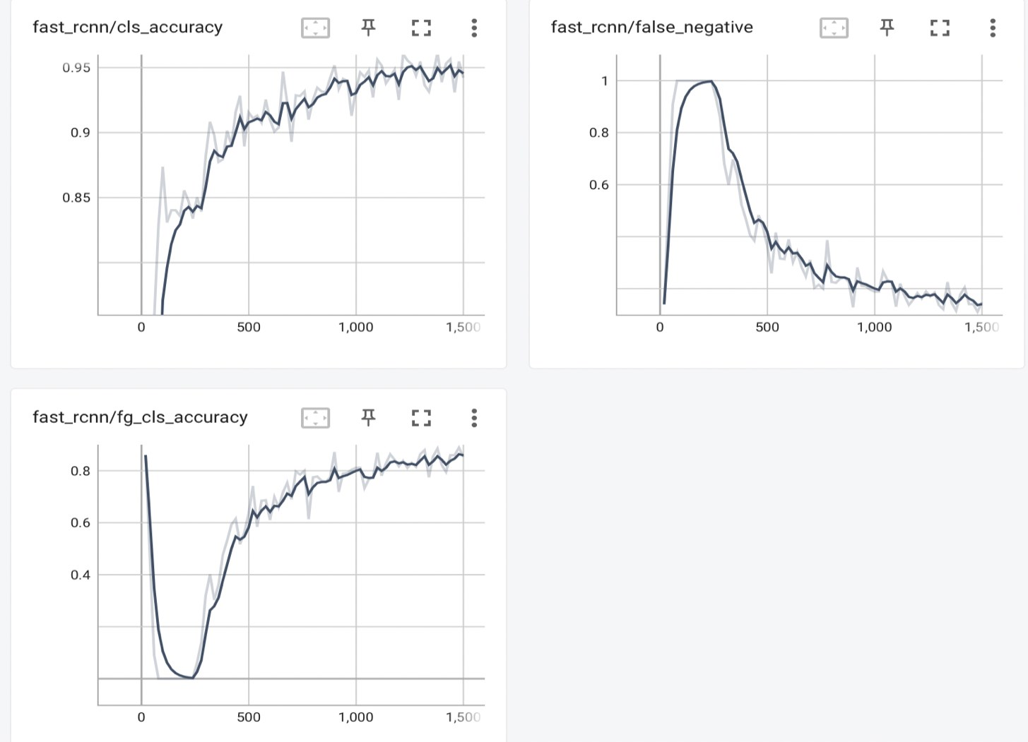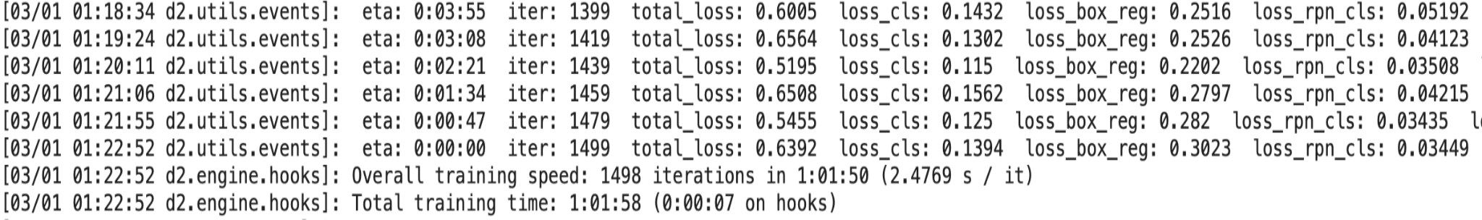

**Visualization of Test Samples and Predicted Results**

**Predicted Results**

Below are the results of **total training loss** with final total_loss value of **0.6392** for 1500 iterations.

Below is the final **AP50 Accuracy** for the final trained model. The final model has a best AP50 value of **59.926**.

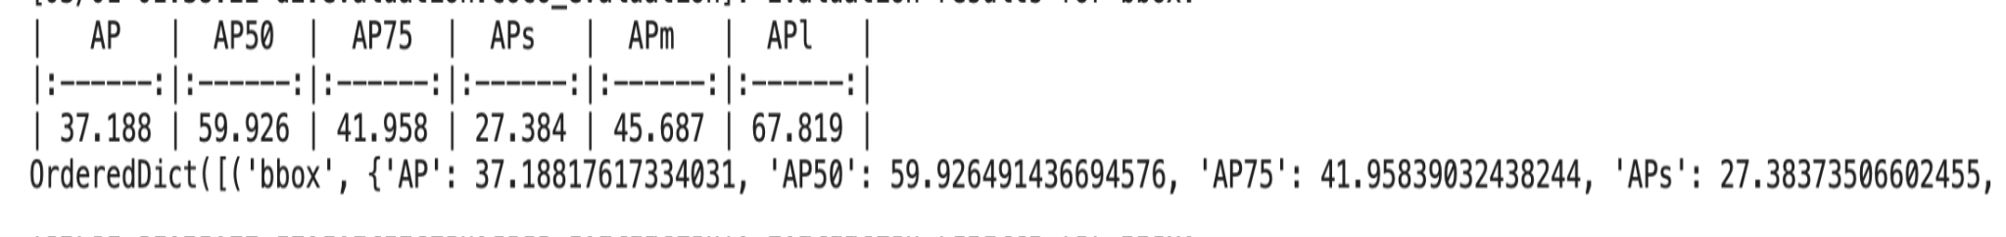

**Visualization of 3 Test Samples**

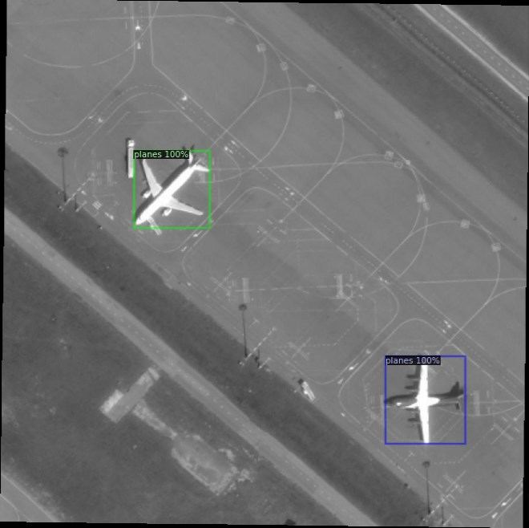**Test Sample 1**

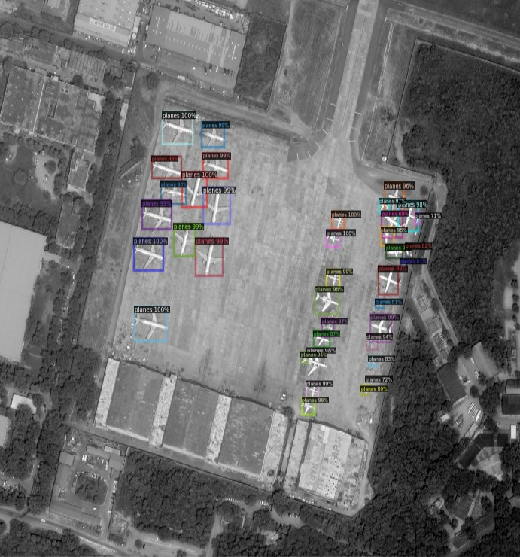**Test Sample 2**

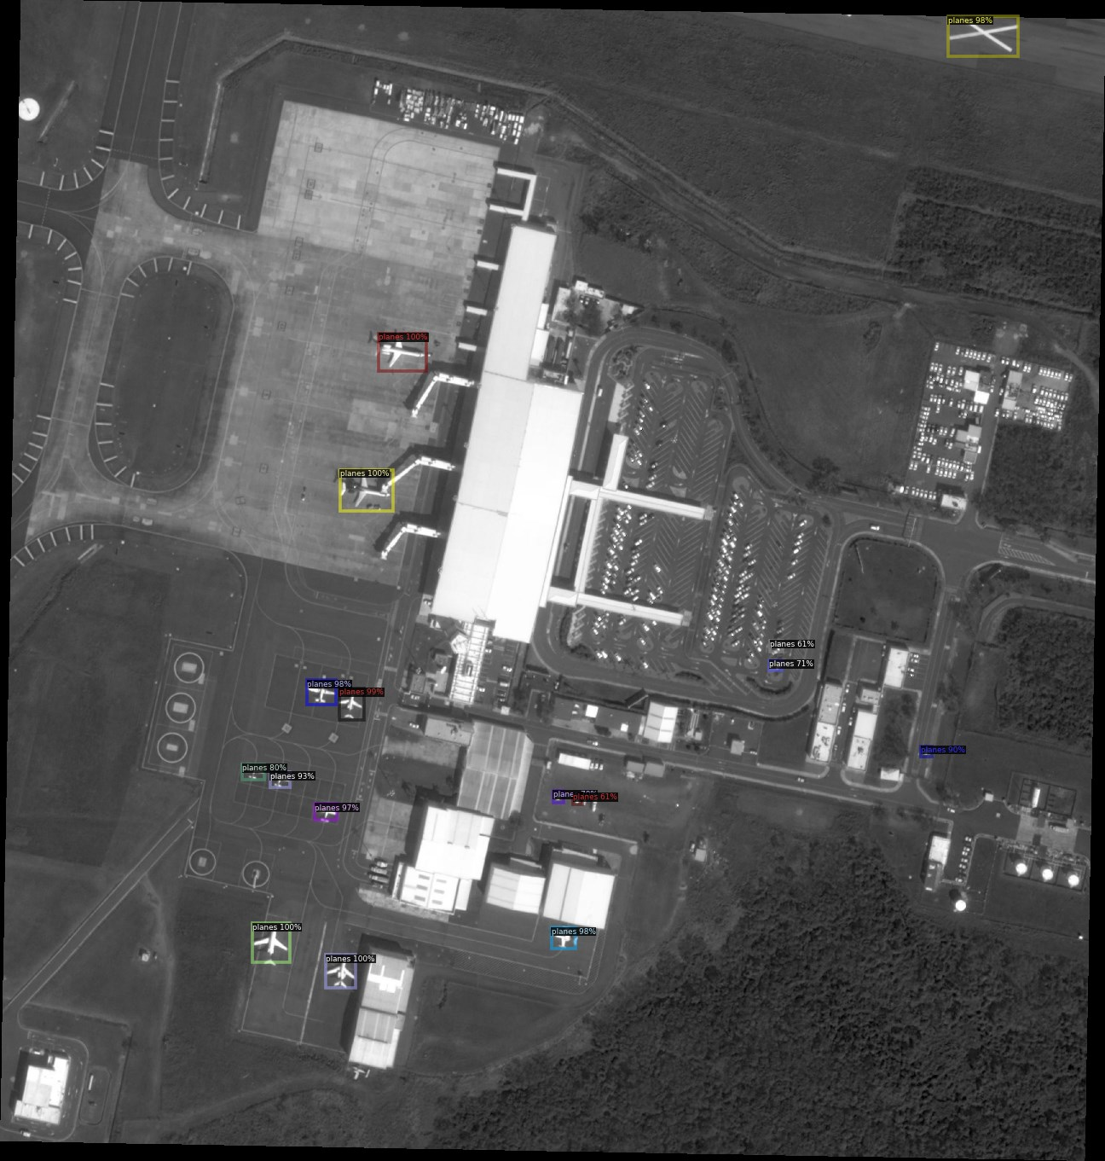**Test Sample 3**

**Ablation Study**

**For Configs**

● Initially, the model is trained with number of workers = 2, maximum iterations = 500 and, original original COCO dataset with original FPN model,

“**COCO-Detection/faster_rcnn_R_101_FPN_3x.yaml**”. The results were not so convincing. As explained in the improvement part, “number of workers” value was increased and set to 4. Similarly, the FPN model was switched to

“**COCO-Detection/faster_rcnn_X_101_32x8d_FPN_3x.yaml**”. Initially the total loss was **0.8321** and AP50 had value **46.82**.

● For the rest of the training attempts, “**number of workers”** was fixed to 4, and “**COCO dataset model**” was fixed with a faster version of “**FPN model**”. The model is trained with “**number of iterations**” equals 500, 1000, and 1500. Lower total training losses and better AP50 accuracy was recorded with increasing the number of iterations.

**Visualizations, total_loss and AP50 accuracy**

**● With 500 iterations:**

**total_loss** = 0.7901 and **AP50 =** 51.210

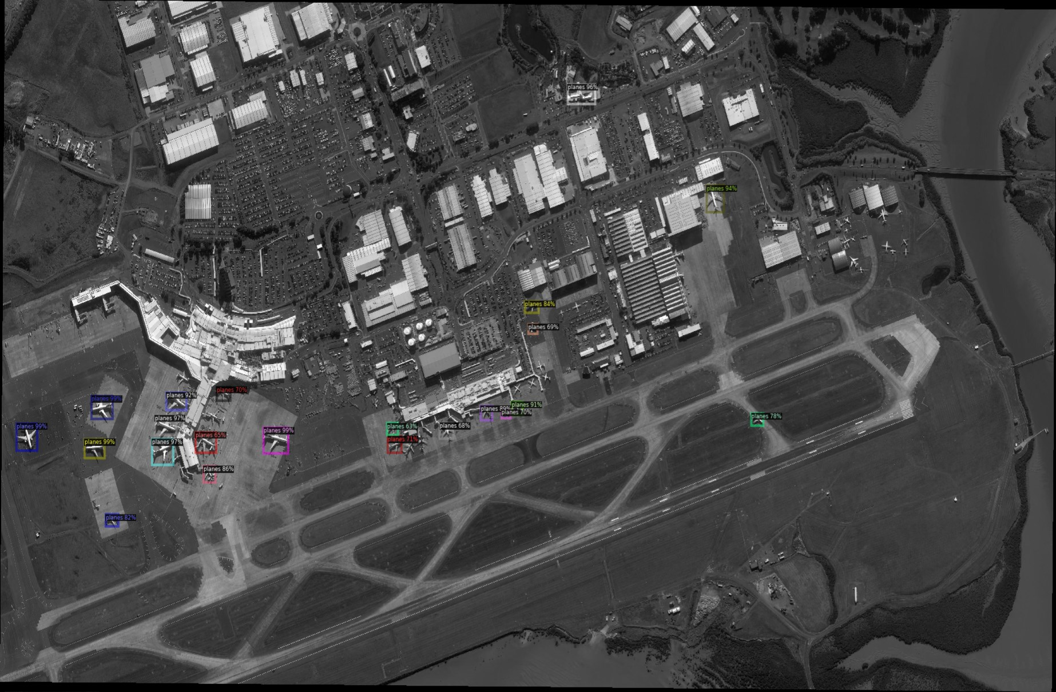Blow is the Visualization of test sample

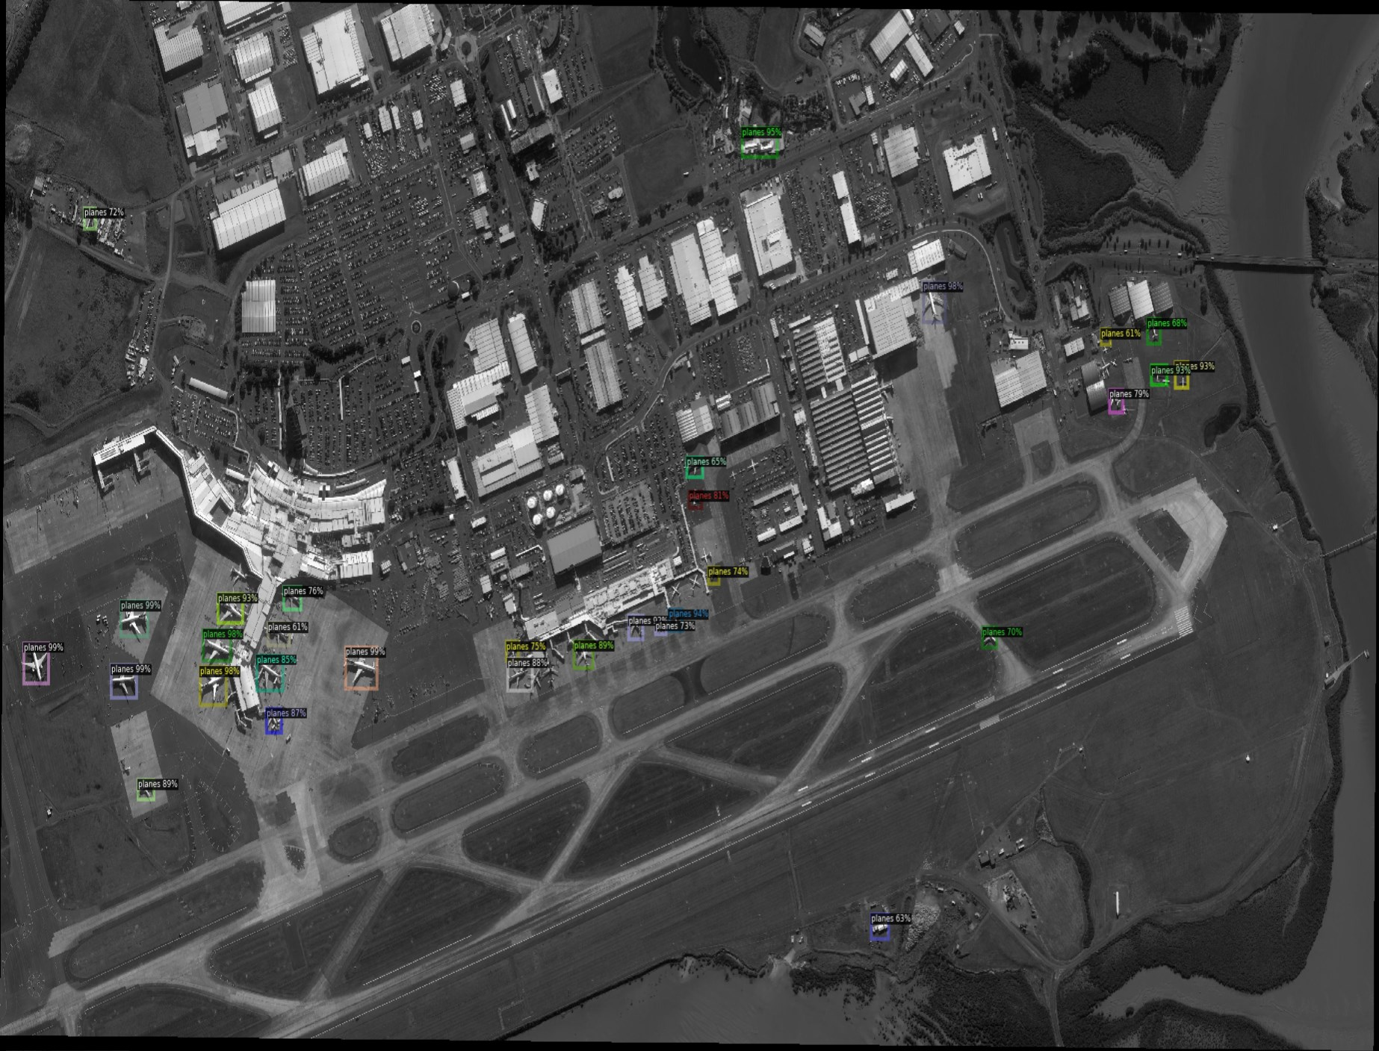

**● With 1000 iterations:**

The total loss is decreased and the AP50 has better accuracy then the model which was trained with 500 iteartions.

**total_loss** = 0.7194 and AP50 = 55.633

Below is the same test sample for the model with 1000 iterations.

It is observed that both the test samples above are almost the same. It is hard to distinguish between them. There are some places where the model with 500 iterations was showing better results. Later another test sample for both the models are visualized. Below are the test samples.

**Sample for 500 iteration**

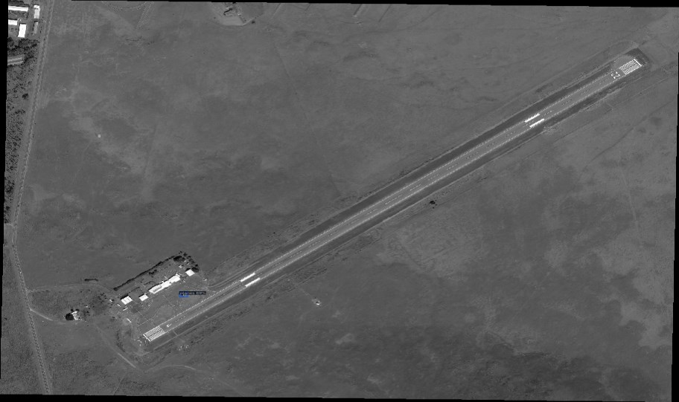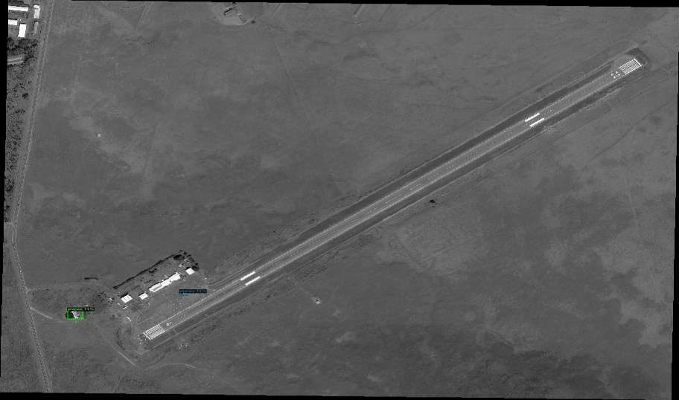

**Sample with 1000 iteration**

The latest model was showing the plane which was not identified by the previous model. So, so far the model with 1000 iterations is a better model than the model with 500 iterations.

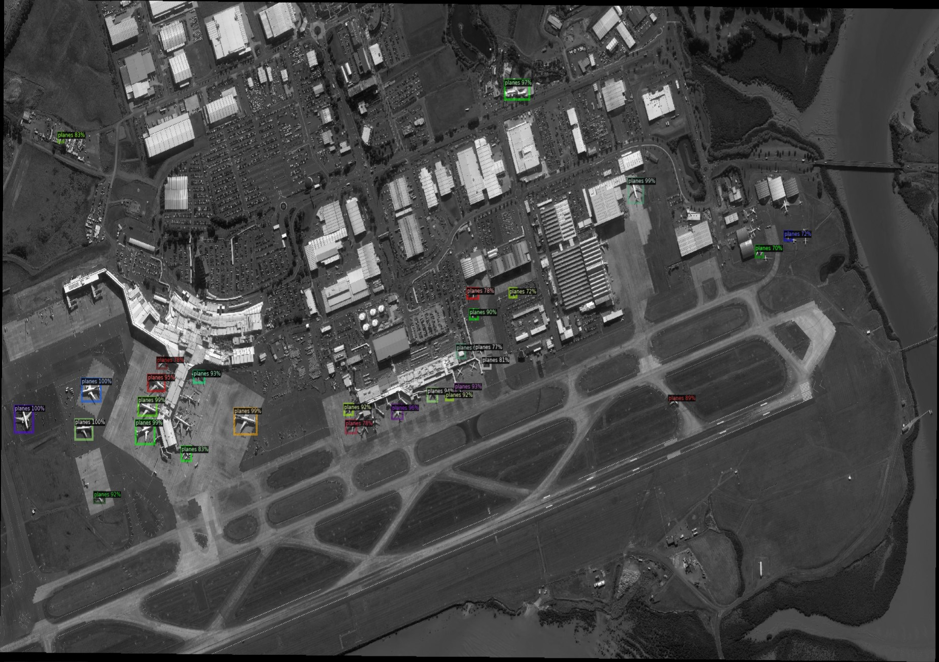

**● With 1500 iterations**

The final model is the best model which on training gives the following results: **total_loss** = 0.6392 and **AP50** = 59.926

Below are the Visualization of test Samples in comparison with older trained models:

**Same test sample for model with 1000 iterations**

The above test sample is better in identifying the planes as compared to the previous models. There are some places where their accuracy is the same. But overall the model with 1500 iterations has shown better visualizations.

Moreover, below is another test sample that will be comparing the models with iterations 1000 and 1500.

**With 1000 iterations**

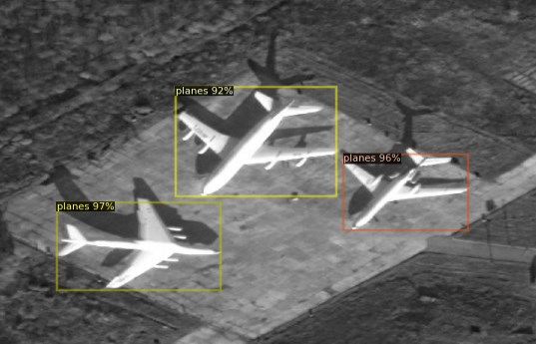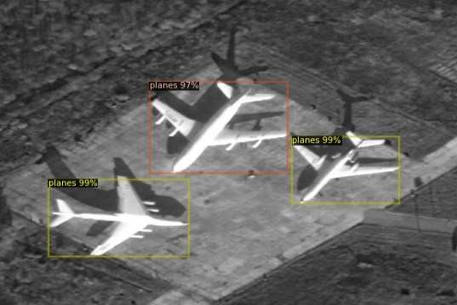

**With 1500 Iterations**

The model with 1500 iterations came out to be the best model than all other models trained before it. Hence, it was fixed as the final model. The code for the trained model of part 1 is provided in the lab3.ipynb file in submission.

**Part 2: Semantic Segmentation**

In this part of the project, it is asked to implement and train a deep neural network for image segmentation tasks. The same dataset was used.

**Hyperparameter Setting**

**● Batch Size =** 4

**● Learning rate =** 0.001 **● Number of epochs =** 80

● **Optimizer =** SGD optimizer

**Final Network Architecture**

In the final network, I added 4 more down sampling and up sampling layers. I also added 1 more conv layer in the down class or down sampling layers. It is done to detect the detailed features as with addition of conv layer, feature channels were also increasing. The down sampling layer was given input as (3, 64) and for each down sampling layer, the output was increased up to double the size of the input. In some layers, it was increased to half of the size of the input. Similarly, for up sampling layers the same trend was followed. The output was decreased up to half of the input. I kept the same SGD optimizer in the final network. The model was trained with epochs ranging from 60-80. The loss was stable and the model was showing better results on training with 80 epochs.

**Loss Function and Plot for the Training Loss**

With the above-mentioned architecture of the network, the final loss recorded was **0.0806**. The default loss function, **nn.BCEWithLogistsLoss()** is used.

**Plot for total Training Loss**

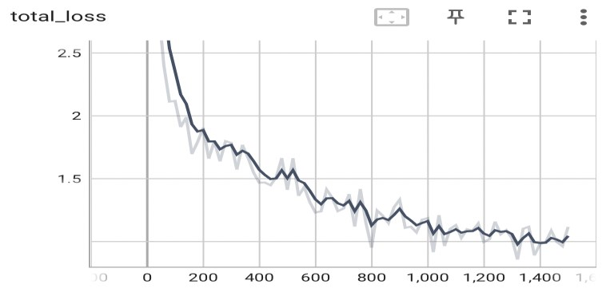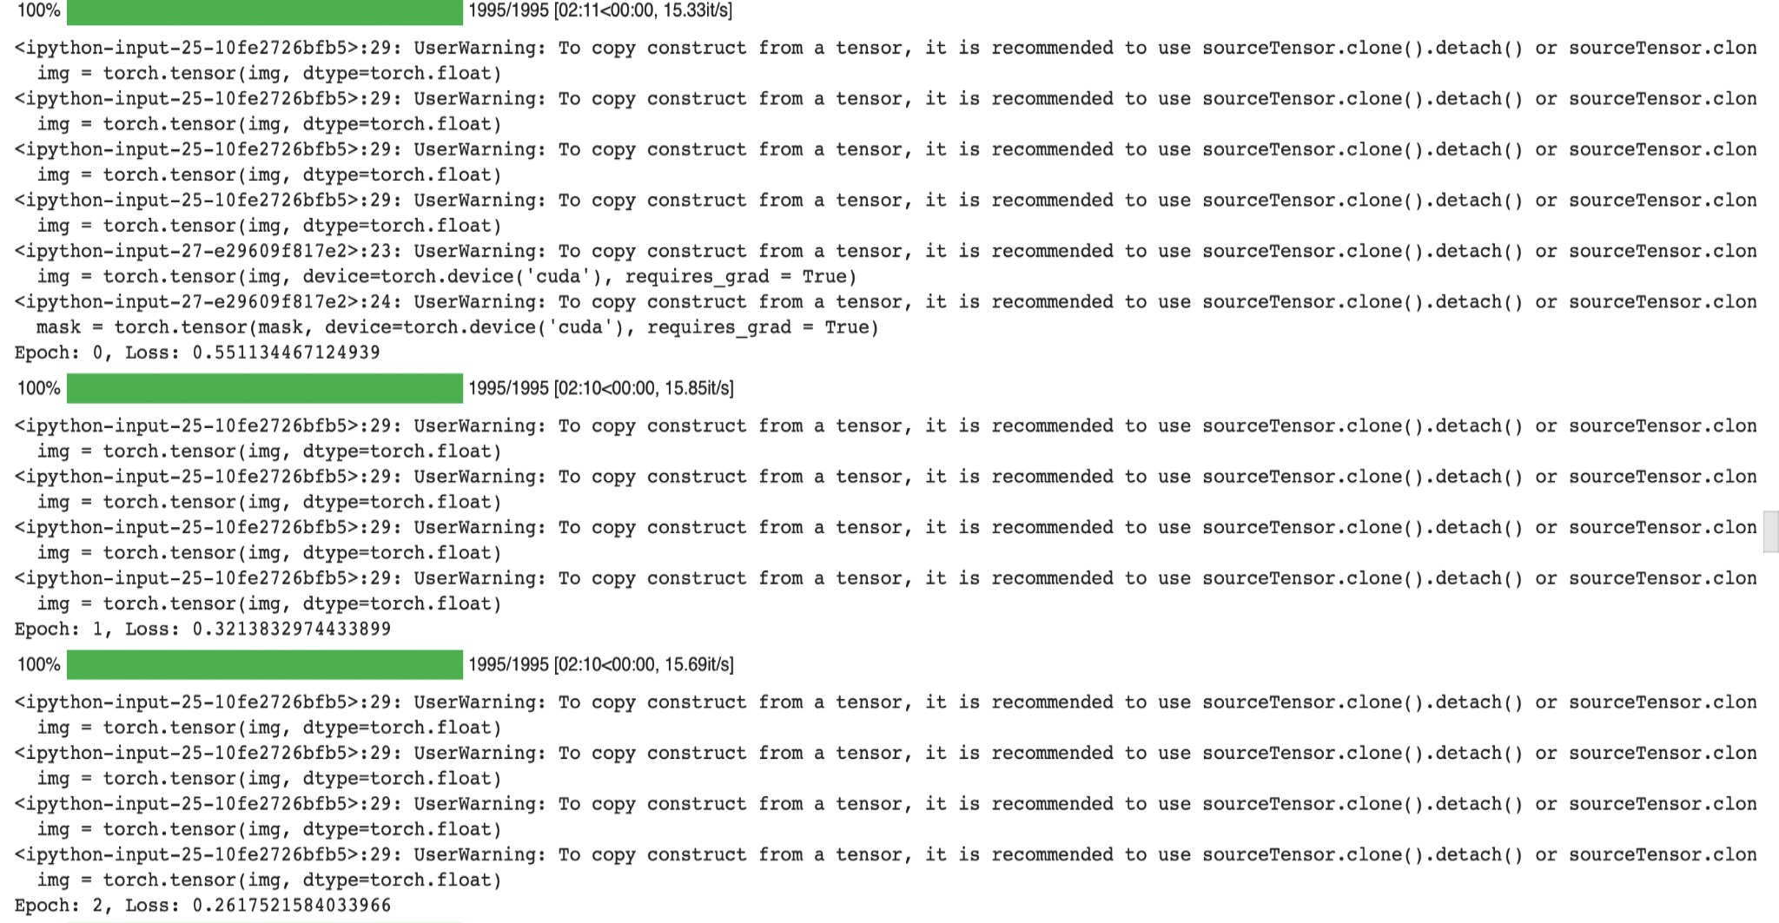

Below are the first 3 and last 3 training losses recorded after training the network:

**First 3 Losses**

Initially the loss started with **0.5511344**.

**Final 3 Losses**

The loss was reduced to **0.08068** for the final epoch training as shown below

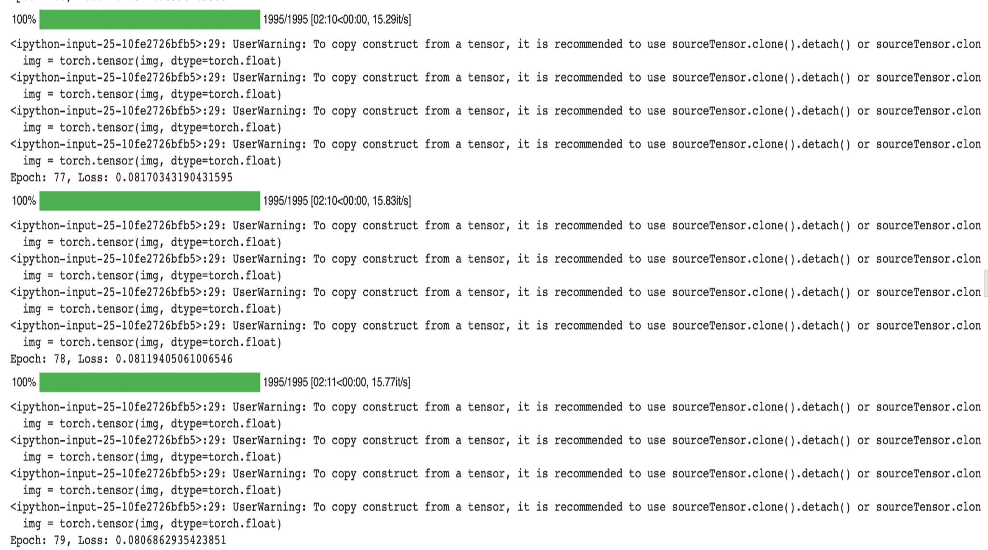

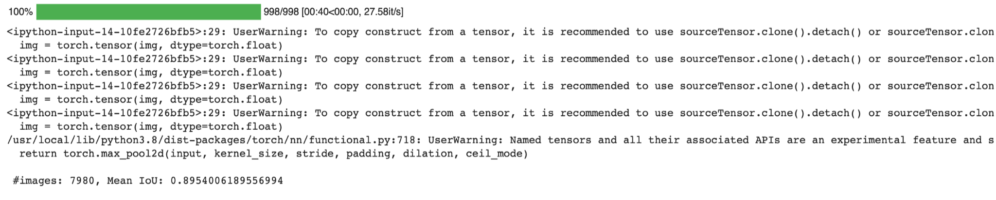

**Final Mean IoU**

The final Mean Iou was recorded with the value of **0.8954006189556994** as shown below:

**Visualize Image from Test Sets**

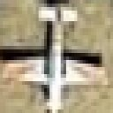**Sample Test 1( original, Ground Truth, Predicted)**

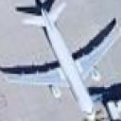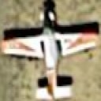

**Sample Test 2( original, Ground Truth, Predicted)**

**Sample Test 3( original, Ground Truth, Predicted)**

**Part 3: Instance Segmentation**

After training the model in both the above parts, the predictions are done on the test sample and the pred.csv file is submitted into the kaggle under:

**Kaggle id-**sps10 **Best score :** 0.82496

**Visualizations of 3 random samples from Test set**

**Sample 1(original, predicted)**

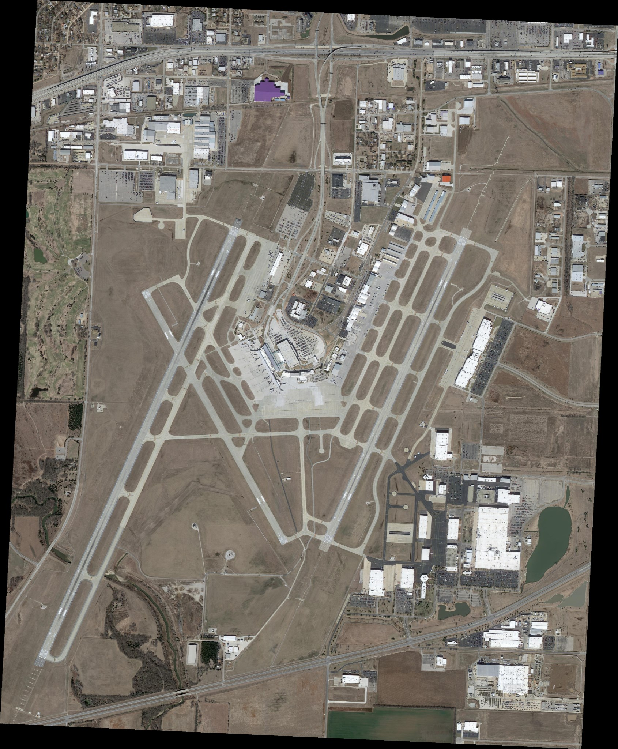



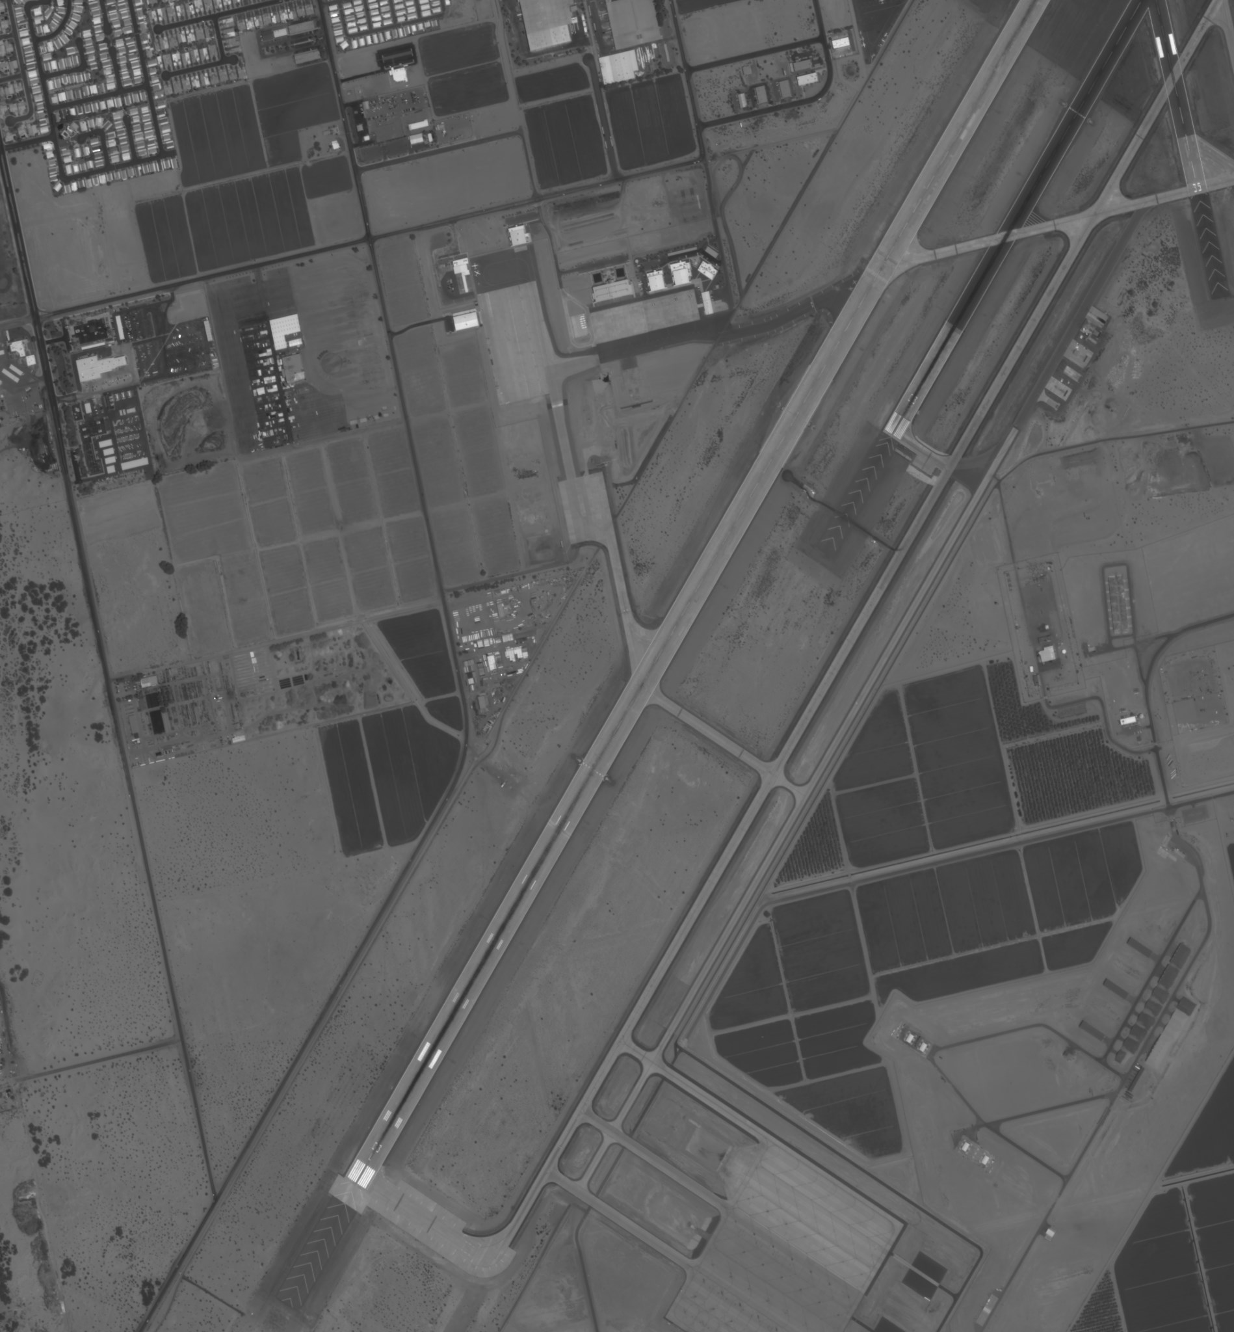**Sample 2(original, predicted)**



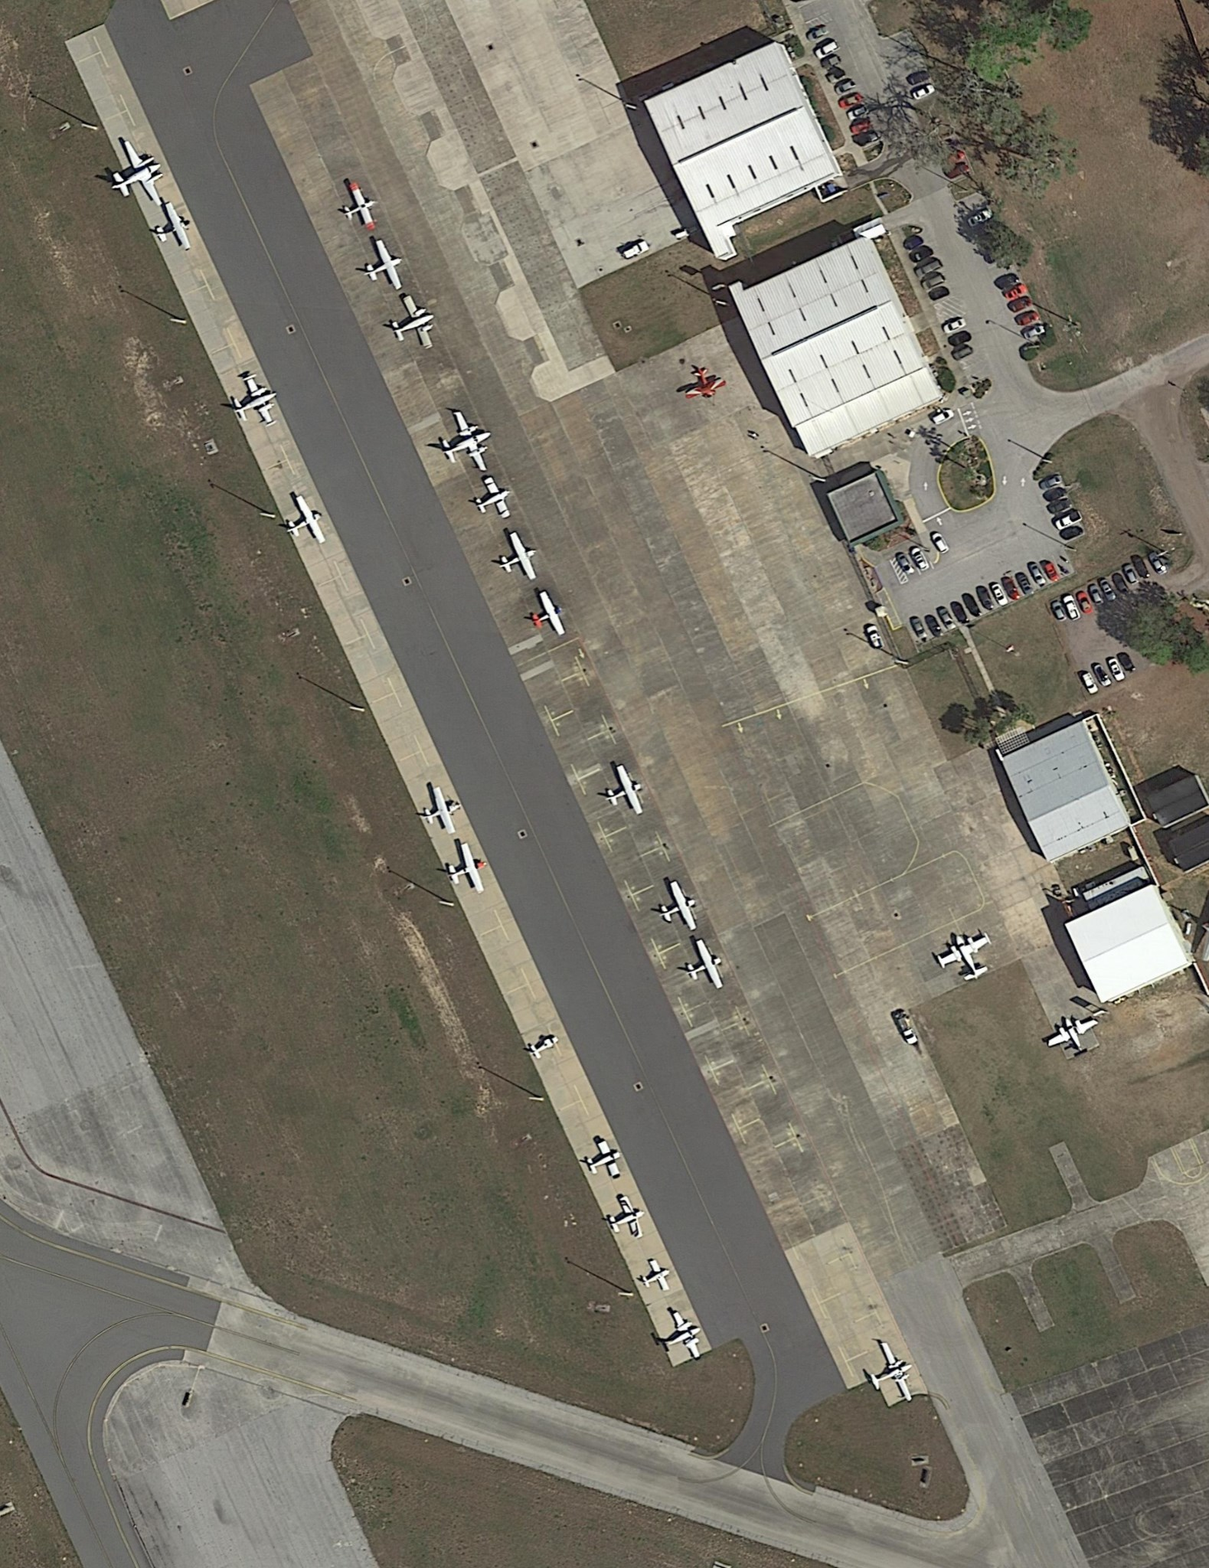**Sample 3(original, predicted)**

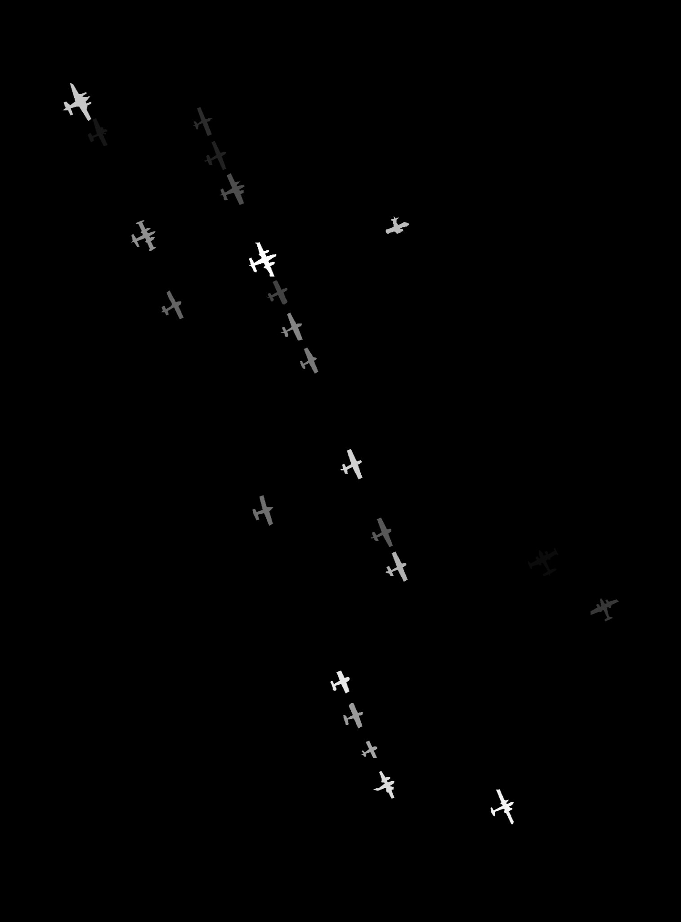

**Part 4: Mask R-CNN**

**Visualization and Evaluation**

Below are the 3 random samples of this model:

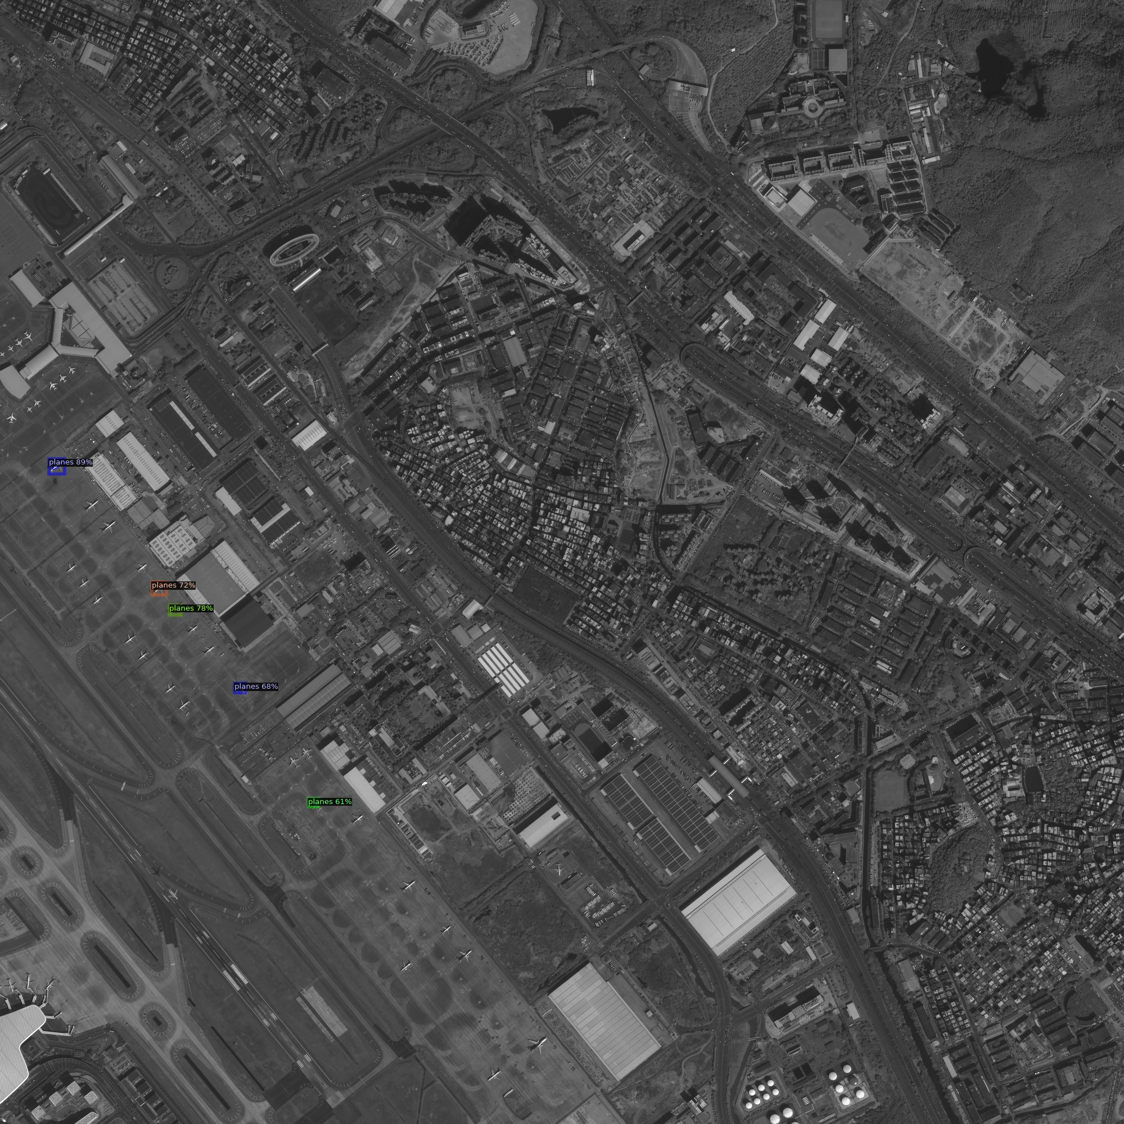**Sample1**

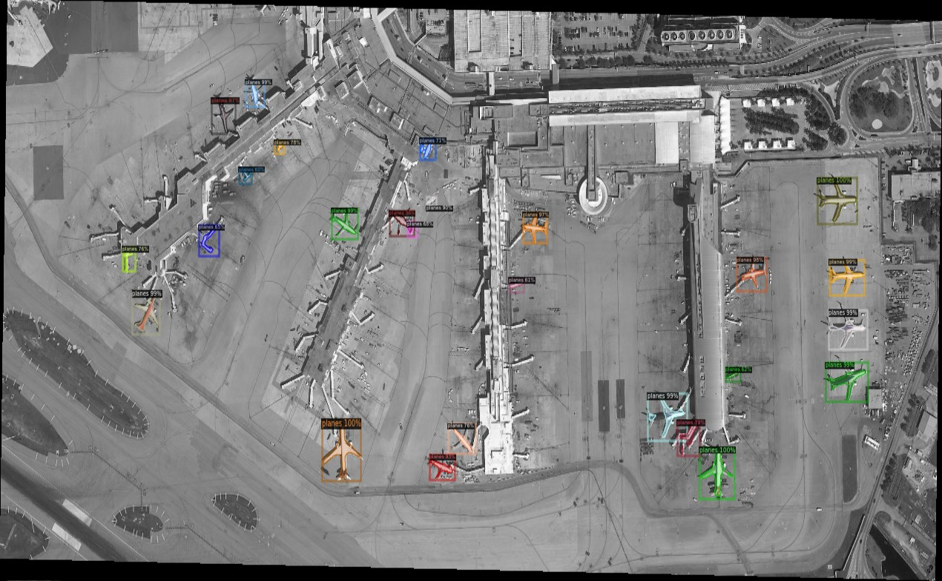

**Sample2**

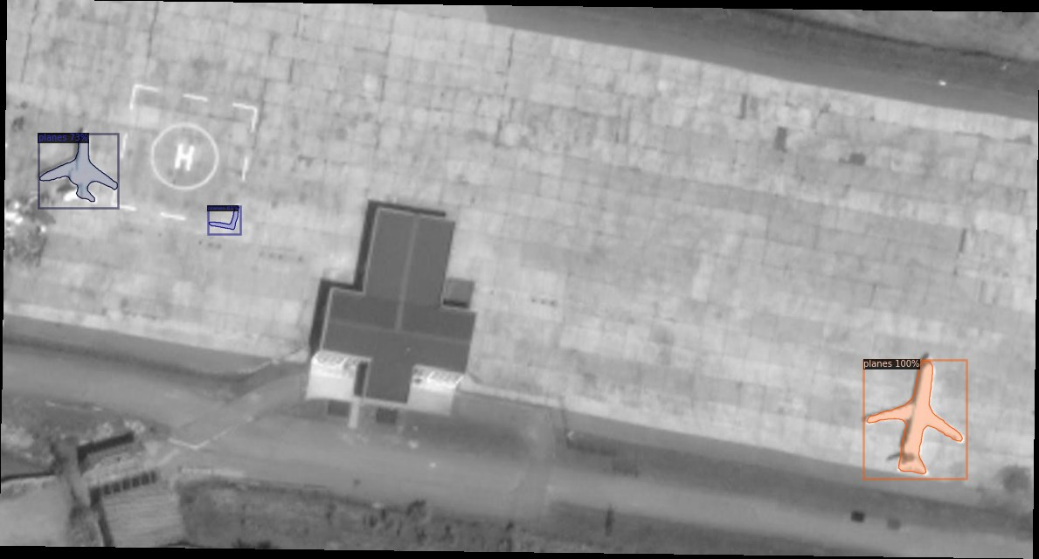**Sample 3**

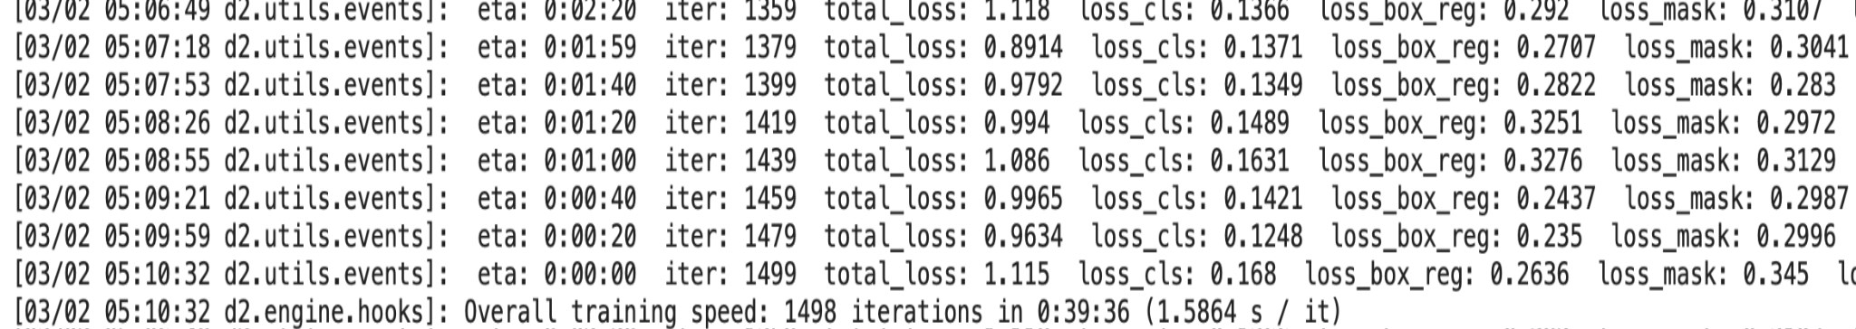

**Evaluation**

The total loss recorded in this model is **1.115**. Moreover, the **AP50** was recorded as **38.672.**

Below is the total_loss at the end of 1500 iterations of this model.

**Difference Between Results**

It is clearly observed that the part 1 model is better than this part’s model. The **AP50** value is only 38.672 in part 4 whereas part 1 has recorded the value of the same as 59.6. Similarly, the total_loss in both part 3 and part 1 is much less than the loss in this part. The values are already provided in their respective parts. The final Mean Iou in part 3 was recorded at about 89.9. After comparing the values of all the factors, it can be said that the accuracy of the model in par4 should be less than the part 3. The same can be seen from the visualizations provided above. However, there is an advantage of this model. It takes less time to train and it doesn’t require images to be cached. This all saves memory and time. Overall, part 3 is a much better and accurate model on this project.

Code for all the parts is written in the **lab3.ipynb** file, provided in the submission.